# ArrayQueue 1

Looking at the Queue below; Follow the code executions and write in the current state of the Array at Each state.

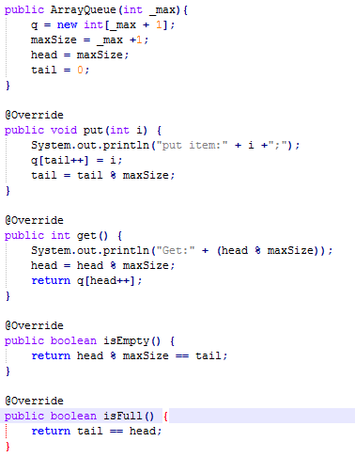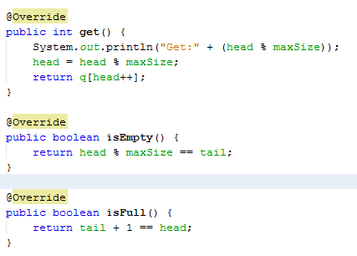

|  |  |  |  |  |  |  |  |  |  |  |  |  |  |  |  |  |  |
| --- | --- | --- | --- | --- | --- | --- | --- | --- | --- | --- | --- | --- | --- | --- | --- | --- | --- |
| **State** | **Code** |  | | **Tail** | | | | | | **T** | | **Head** | | | **H** | |  |
|  |  |  | |  | | | | | |  | |  | | |  | |  |
|  | ArrayQueue q = new ArrayQueue(10) |  | |  | |  | | T | |  |  |  |  |  |  |  | H |
|  | Put(5) | **A** | | 5 | | 18 | |  | |  |  |  |  |  |  |  |  |
| **A** | Put(18) |  | | isEmpty() | | | | | | False | | isFull() | | | False | |  |
|  |  |  | |  | | | | | |  | |  | | |  | |  |
|  | Get() |  | |  | | H | |  | |  | T |  |  |  |  |  |  |
|  | Put(14) | **B** | | 5 | | 18 | | 14 | | 75 |  |  |  |  |  |  |  |
| **B** | Put(75) |  | | isEmpty() | | | | | | False | | isFull() | | | False | |  |
|  |  |  | |  | | | | | |  | |  | | |  | |  |
|  | Put(86) |  | |  | |  | | H | |  |  |  | T |  |  |  |  |
|  | Put(15) | **C** | | 5 | | 18 | | 14 | | 75 | 86 | 15 |  |  |  |  |  |
| **C** | Get() |  | | isEmpty() | | | | | | False | | isFull() | | | False | |  |
|  |  |  | |  | | | | | |  | |  | | |  | |  |
|  | Put(13) |  | |  | |  | | H | |  |  |  |  |  |  | T |  |
|  | Put(41) | **D** | | 5 | | 18 | | 14 | | 75 | 86 | 15 | 13 | 41 | 91 |  |  |
| **D** | Put(91) |  | | isEmpty() | | | | | | False | | isFull() | | | False | |  |
|  |  |  | |  | | | | | |  | |  | | |  | |  |
|  | Put(62) |  | | H | | T | |  | |  |  |  |  |  |  |  |  |
|  | Put(53) | **E** | | 19 | | 18 | | 14 | | 75 | 86 | 15 | 13 | 41 | 91 | 62 | 53 |
| **E** | Put(19) |  | | isEmpty() | | | | | | False | | isFull() | | | True | |  |
|  |  |  | |  | | | | | |  | |  | | |  | |  |
|  | Get() |  | |  | | T | |  | |  |  | H |  |  |  |  |  |
|  | Get() | **F** | | 19 | | 18 | | 14 | | 75 | 86 | 15 | 13 | 41 | 91 | 62 | 53 |
| **F** | Get() |  | | isEmpty() | | | | | | False | | isFull() | | | False | |  |
|  |  |  | |  | | | | | |  | |  | | |  | |  |
|  | Get() |  | |  | |  | | T | |  |  |  |  | H |  |  |  |
|  | Get() | **G** | | 19 | | 33 | | 14 | | 75 | 86 | 15 | 13 | 41 | 91 | 62 | 53 |
| **G** | Put(33) |  | | isEmpty() | | | | | | False | | isFull() | | | False | |  |
|  |  |  | |  | | | | | |  | |  | | |  | |  |
|  | Put(45) | |  | |  | |  | |  | T |  |  |  |  |  | H |  |
|  | Get() | | **H** | | 19 | | 33 | | 45 | 75 | 86 | 15 | 13 | 41 | 91 | 62 | 53 |
| **H** | Get() | |  | | isEmpty() | | | | | False | | isFull() | | | False | |  |
|  |  | |  | |  | | | | |  | |  | | |  | |  |
|  | Get() | |  | | H | |  | |  |  | T |  |  |  |  |  |  |
|  | Get() | | **I** | | 19 | | 33 | | 45 | 29 | 86 | 15 | 13 | 41 | 91 | 62 | 53 |
| **I** | Put(29) | |  | | isEmpty() | | | | | False | | isFull() | | | False | |  |
|  |  | |  | |  | | | | |  | |  | | |  | |  |
|  | Put(45) | |  | |  | | H | |  |  |  | T |  |  |  |  |  |
|  | Get() | | **J** | | 19 | | 33 | | 45 | 29 | 45 | 15 | 13 | 41 | 91 | 62 | 53 |
| **J** | **Final State** | |  | | isEmpty() | | | | | False | | isFull() | | | False | |  |